Order Of Lenten Service

Opening Hymn: TLH 144

Reading: Lent IV

The History of the Passion of our Lord

Sermon Hymn: TLH 514

Sermon Text: Song Of Solomon 5:15b

His Countenance

Prayer

Holy Communion

The Lord's Prayer

The Blessing

Closing Hymn: TLH 175

* * * * * * * * * * * * *

Bible Study: Lambs: Three Salamanders
Sheep: Proverbs 13:21-25

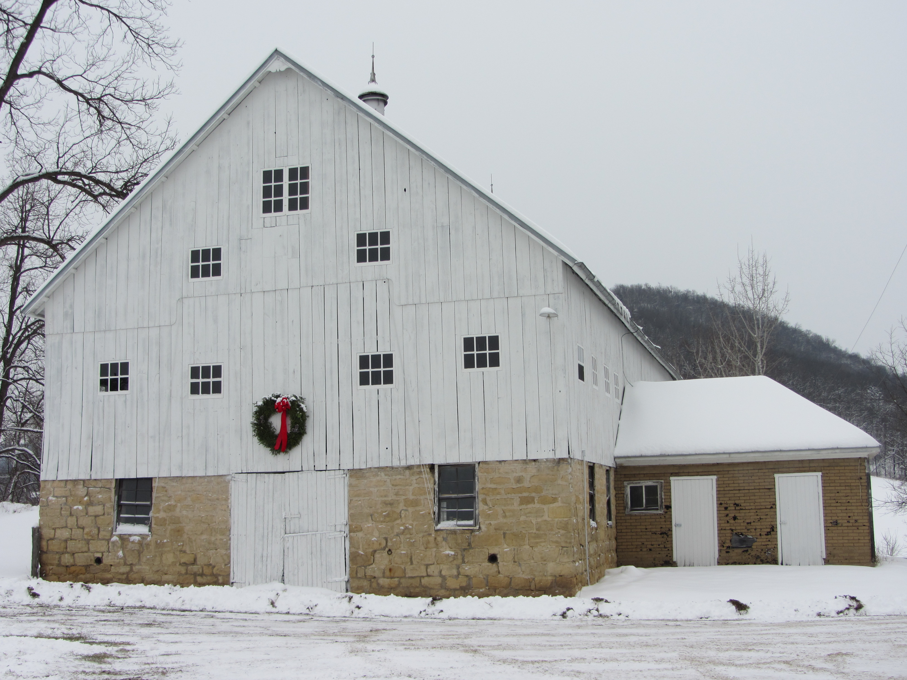

Winter At MGMF

Water
Of
Life

19 March 2017

W A T E R O F L I F E

Independent Christian Church—Conservative Lutheran Doctrine

Worship Service: 9:30 a.m. Bible Study: 10:45 a.m.

Larry Cooper, Pastor E-Mail address:
111 N. Ridge Road lcooper@wateroflife.cc
Coon Valley, WI 54623 Web Site:
Phone: (608) 452-2105 www.wateroflife.cc

* * * * * * * * * * * * * * * * * * * * * * * * * * *

Sermon Text: Song Of Solomon 5:15b

His Countenance

* * * * * * * * * * * * * * * * * * * * * * * * * * *

Song of Solomon 5:15b His countenance is as Lebanon, excellent as the cedars.

Elephant Island

The ship named Endurance sailed away from South Georgia Island and headed toward the ice pack in the Weddell Sea. The expedition, headed by Sir Ernest Shackleton, was to land at Vahsel Bay in the Antarctic. From there, they would leave the ship and cross the continent—a feat that had never been accomplished.

They never made it. One short day away from landing at Vahsel Bay, Endurance became caught in the ice pack. A short time later, miles from land, she was crushed in the ice and sunk into the ocean. Leaving their camp on an ice flow, the crew of 28 men traveled in search of land in three small lifeboats. Finally, they landed on Elephant Island. Safe at last from the Weddell Sea.

But their joy was short lived. Elephant Island turned out to be a hellish prison. There was hardly any place to land the boats and set up camp. Solid-rock cliffs rose some 800 feet straight into the air. Nothing could grow there. And the weather was bitter cold. It was one of the most desolate places on the earth.

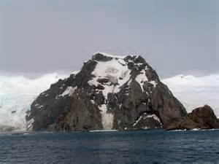

How to summarize Elephant Island? Two words. “Bitter disappointment!”

How different it is with the Bridegroom! His countenance is as Lebanon, excellent as the cedars.

